**Exercise 2**

1. **Display the Supplier table in the descending order of CITY.**

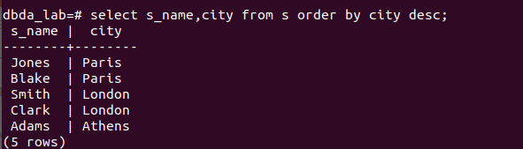

1. **Display the Part Table in the ascending order of CITY and within the city in the ascending order of Part names.**

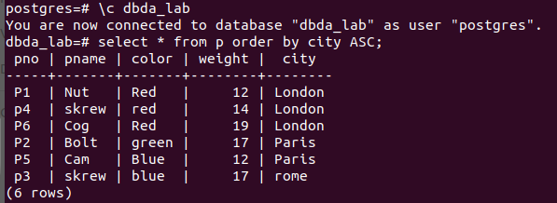

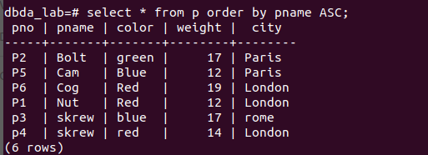

1. **Display all the Suppliers with a status between 10 and 20.** 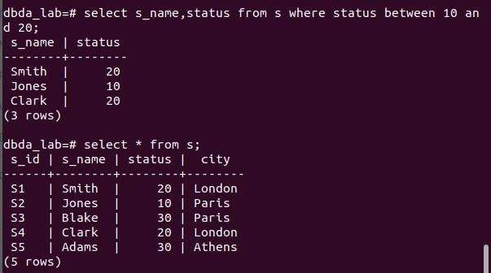
2. **Display all the Parts and their Weight, which are not in the range of 10 and 15.**

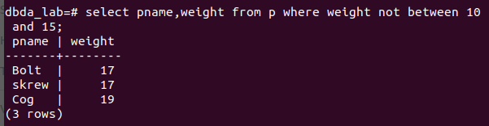

1. **Display all the Part names starting with the letter ‘S’.**

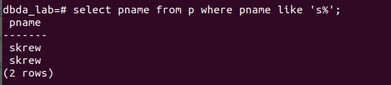

1. **Display all the Suppliers, belonging to cities starting with the letter ‘L’.**

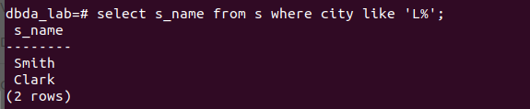

1. **Display all the Projects, with the third letter in JNAME as ‘n’.**

